**Перший рівень**

| **Test Case ID** | | Tc01 | **Test Case Description** | | Test the Login Functionality in automoto.ua | | | | | |
| --- | --- | --- | --- | --- | --- | --- | --- | --- | --- | --- |
| **Created By** | | Taras | **Reviewed By** | | Taras | | **Version** | | 2.1 | |
|  |  |  |  |  |  |  |  |  |  |  |
| **QA Tester’s Log** | | Review comments from Taras incorprate in version 2.1 | | |  |  |  |  |  |  |
|  |  |  |  |  |  |  |  |  |  |  |
| **Tester's Name** | | Taras | **Date Tested** | | 25.02.2023 | | **Test Case (Pass/Fail/Not Executed)** | | Pass | |
|  |  |  |  |  |  |  |  |  |  |  |
| **S #** | **Prerequisites:** | | |  | **S #** | **Test Data** | | | | |
| 1 | Access to Chrome Browser | | |  | 1 | +380681939088 | | | | |
| 2 |  | | |  | 2 |  | | | | |
| 3 |  | | |  | 3 |  | | | | |
| 4 |  | | |  | 4 |  | | | | |
|  |  |  |  |  |  |  |  |  |  |  |
| **Test Scenario** | Log in with mobile phone number | | |  | **Expected result** | Log in website personal account | | | |  |
|  |  |  |  |  |  |  |  |  |  |  |
| **Step #** | **Step Details** | | **Expected Results** | | **Actual Results** | | | **Pass / Fail / Not executed / Suspended** | | |
|
| 1 | Navigate to https://automoto.ua/ | | Site should open | | As Expected | | | Pass | | |
| 2 | In the header click to the portrait Log in | | mobile phone input field will open | | As Expected | | | Pass | | |
| 3 | Enter the number and enter the SMS code that will be sent to your phone | | You have successfully logged in | | As Expected | | | Pass | | |

| **Test Case ID** | | Tc02 | **Test Case Description** | | Search filter test in automoto.ua | | | | | |
| --- | --- | --- | --- | --- | --- | --- | --- | --- | --- | --- |
| **Created By** | | Taras | **Reviewed By** | | Taras | | **Version** | | 2.1 | |
|  |  |  |  |  |  |  |  |  |  |  |
| **QA Tester’s Log** | | Review comments from Taras incorprate in version 2.1 | | |  |  |  |  |  |  |
|  |  |  |  |  |  |  |  |  |  |  |
| **Tester's Name** | | Taras | **Date Tested** | | 25.02.2023 | | **Test Case (Pass/Fail/Not Executed)** | | Pass | |
|  |  |  |  |  |  |  |  |  |  |  |
| **S #** | **Prerequisites:** | | |  | **S #** | **Test Data** | | | | |
| 1 | Access to Chrome Browser | | |  | 1 | Легкові, Марка - Volkswagen | | | | |
| 2 |  | | |  | 2 | Модель Golf | | | | |
| 3 |  | | |  | 3 | Рік 2005-2005 | | | | |
| 4 |  | | |  | 4 | Ціна до 5000$, Область - Запорізька | | | | |
|  |  |  |  |  |  |  |  |  |  |  |
| **Test Scenario** | Car search test by filters | | |  | **Expected result** | The filter returned a car matching our search criteria | | | |  |
|  |  |  |  |  |  |  |  |  |  |  |
| **Step #** | **Step Details** | | **Expected Results** | | **Actual Results** | | | **Pass / Fail / Not executed / Suspended** | | |
|
| 1 | Navigate to https://automoto.ua/ | | Site should open | | As Expected | | | Pass | | |
| 2 | In the center we see the search filter | |  | |  | | | Pass | | |
| 3 | set the filter according to the source data and click search | | The filter returned a car matching our search criteria | | As Expected | | | Pass | | |

| **Test Case ID** | | Tc03 | **Test Case Description** | | Go to the ad page from the main menu automoto.ua | | | | | |
| --- | --- | --- | --- | --- | --- | --- | --- | --- | --- | --- |
| **Created By** | | Taras | **Reviewed By** | | Taras | | **Version** | | 2.1 | |
|  |  |  |  |  |  |  |  |  |  |  |
| **QA Tester’s Log** | | Review comments from Taras incorprate in version 2.1 | | |  |  |  |  |  |  |
|  |  |  |  |  |  |  |  |  |  |  |
| **Tester's Name** | | Taras | **Date Tested** | | 25.02.2023 | | **Test Case (Pass/Fail/Not Executed)** | | Pass | |
|  |  |  |  |  |  |  |  |  |  |  |
| **S #** | **Prerequisites:** | | |  | **S #** | **Test Data** | | | | |
| 1 | Access to Chrome Browser | | |  | 1 |  | | | | |
| 2 |  | | |  | 2 |  | | | | |
| 3 |  | | |  | 3 |  | | | | |
| 4 |  | | |  | 4 |  | | | | |
|  |  |  |  |  |  |  |  |  |  |  |
| **Test Scenario** | Click on any ad on the home page | | |  | **Expected result** | the page with the ad that we clicked opened | | | |  |
|  |  |  |  |  |  |  |  |  |  |  |
| **Step #** | **Step Details** | | **Expected Results** | | **Actual Results** | | | **Pass / Fail / Not executed / Suspended** | | |
|
| 1 | Navigate to https://automoto.ua/ | | Site should open | | As Expected | | | Pass | | |
| 2 | Scroll down in home page | | see more add | | As Expected | | | Pass | | |
| 3 | Click random add | | the page with the ad that we clicked opened | | As Expected | | | Pass | | |

| **Test Case ID** | | Tc04 | **Test Case Description** | | verification of contacts in the ad in automoto.ua | | | | | |
| --- | --- | --- | --- | --- | --- | --- | --- | --- | --- | --- |
| **Created By** | | Taras | **Reviewed By** | | Taras | | **Version** | | 2.1 | |
|  |  |  |  |  |  |  |  |  |  |  |
| **QA Tester’s Log** | | Review comments from Taras incorprate in version 2.1 | | |  |  |  |  |  |  |
|  |  |  |  |  |  |  |  |  |  |  |
| **Tester's Name** | | Taras | **Date Tested** | | 25.02.2023 | | **Test Case (Pass/Fail/Not Executed)** | | Pass | |
|  |  |  |  |  |  |  |  |  |  |  |
| **S #** | **Prerequisites:** | | |  | **S #** | **Test Data** | | | | |
| 1 | Access to Chrome Browser | | |  | 1 |  | | | | |
| 2 |  | | |  | 2 |  | | | | |
| 3 |  | | |  | 3 |  | | | | |
| 4 |  | | |  | 4 |  | | | | |
|  |  |  |  |  |  |  |  |  |  |  |
| **Test Scenario** | Click on the "“контакти продавця”" button in any ad | | |  | **Expected result** | we have to go to the page/web site where we will find the contact details of the seller | | | |  |
|  |  |  |  |  |  |  |  |  |  |  |
| **Step #** | **Step Details** | | **Expected Results** | | **Actual Results** | | | **Pass / Fail / Not executed / Suspended** | | |
|
| 1 | Navigate to https://automoto.ua/ | | Site should open | | As Expected | | | Pass | | |
| 2 | Scroll down in home page | | see more add | | As Expected | | | Pass | | |
| 3 | Click random add | | the page with the ad that we clicked opened | | As Expected | | | Pass | | |
| 4 | Сlick button “контакти продавця” | | we have to go to the page/web site where we will find the contact details of the seller | | As Expected | | | Pass | | |

| **Test Case ID** | | Tc0 | **Test Case Description** | | Checking the feedback form with a car dealership in automoto.ua | | | | | |
| --- | --- | --- | --- | --- | --- | --- | --- | --- | --- | --- |
| **Created By** | | Taras | **Reviewed By** | | Taras | | **Version** | | 2.1 | |
|  |  |  |  |  |  |  |  |  |  |  |
| **QA Tester’s Log** | | Review comments from Taras incorprate in version 2.1 | | |  |  |  |  |  |  |
|  |  |  |  |  |  |  |  |  |  |  |
| **Tester's Name** | | Taras | **Date Tested** | | 25.02.2023 | | **Test Case (Pass/Fail/Not Executed)** | | Pass | |
|  |  |  |  |  |  |  |  |  |  |  |
| **S #** | **Prerequisites:** | | |  | **S #** | **Test Data** | | | | |
| 1 | Access to Chrome Browser | | |  | 1 | Tel: 123214321412412 | | | | |
| 2 |  | | |  | 2 | Name: 12312312 | | | | |
| 3 |  | | |  | 3 |  | | | | |
| 4 |  | | |  | 4 |  | | | | |
|  |  |  |  |  |  |  |  |  |  |  |
| **Test Scenario** | We enter invalid data in the feedback form with a car dealership | | |  | **Expected result** | Fields should highlight the error and indicate invalid input | | | |  |
|  |  |  |  |  |  |  |  |  |  |  |
| **Step #** | **Step Details** | | **Expected Results** | | **Actual Results** | | | **Pass / Fail / Not executed / Suspended** | | |
|
| 1 | Navigate to https://automoto.ua/ | | Site should open | | As Expected | | | Pass | | |
| 2 | In the header click to the button “Автосалони” | | Open page “автосалони” | | As Expected | | | Pass | | |
| 3 | Click button on random dealership “Зворотній зв’язок” | | There is a feedback form | | As Expected | | | Pass | | |
| 4 | Fill out the form and click button “Відправити” | | We should see an invalid input error. | | As Expected | | | Pass | | |

**Другий рівень:**

* **LIST USERS - при вводе несуществующей страницы выдает статус 200 вместо 404, и открывает страницу номер 6**

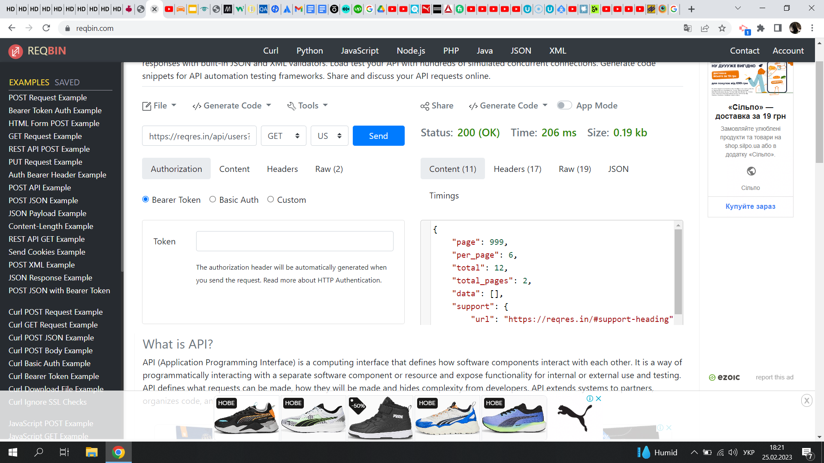

* **LOGIN - SUCCESSFUL - валидный токен при неверном пароле**

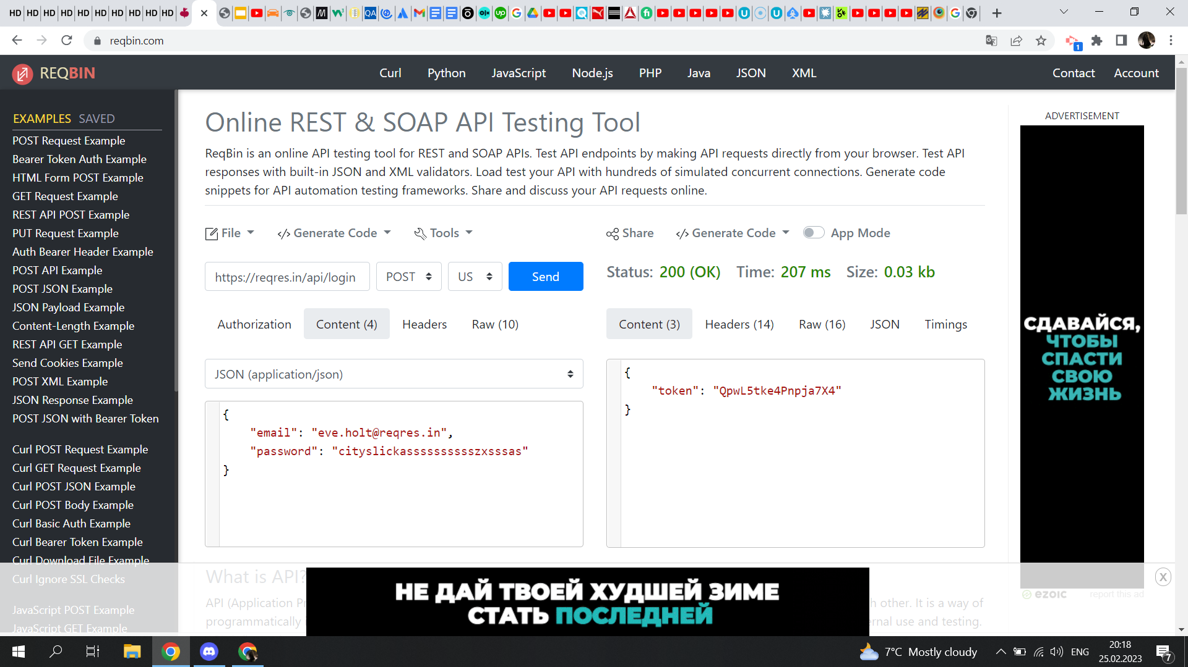

**Третій рівень:**

**Create a new user**

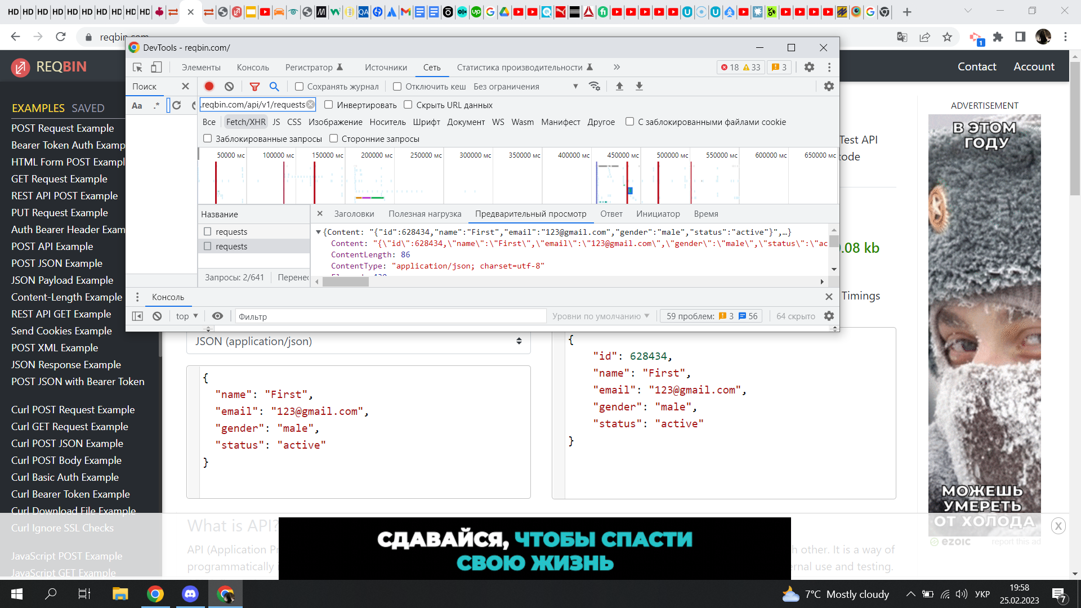

**Get user details**

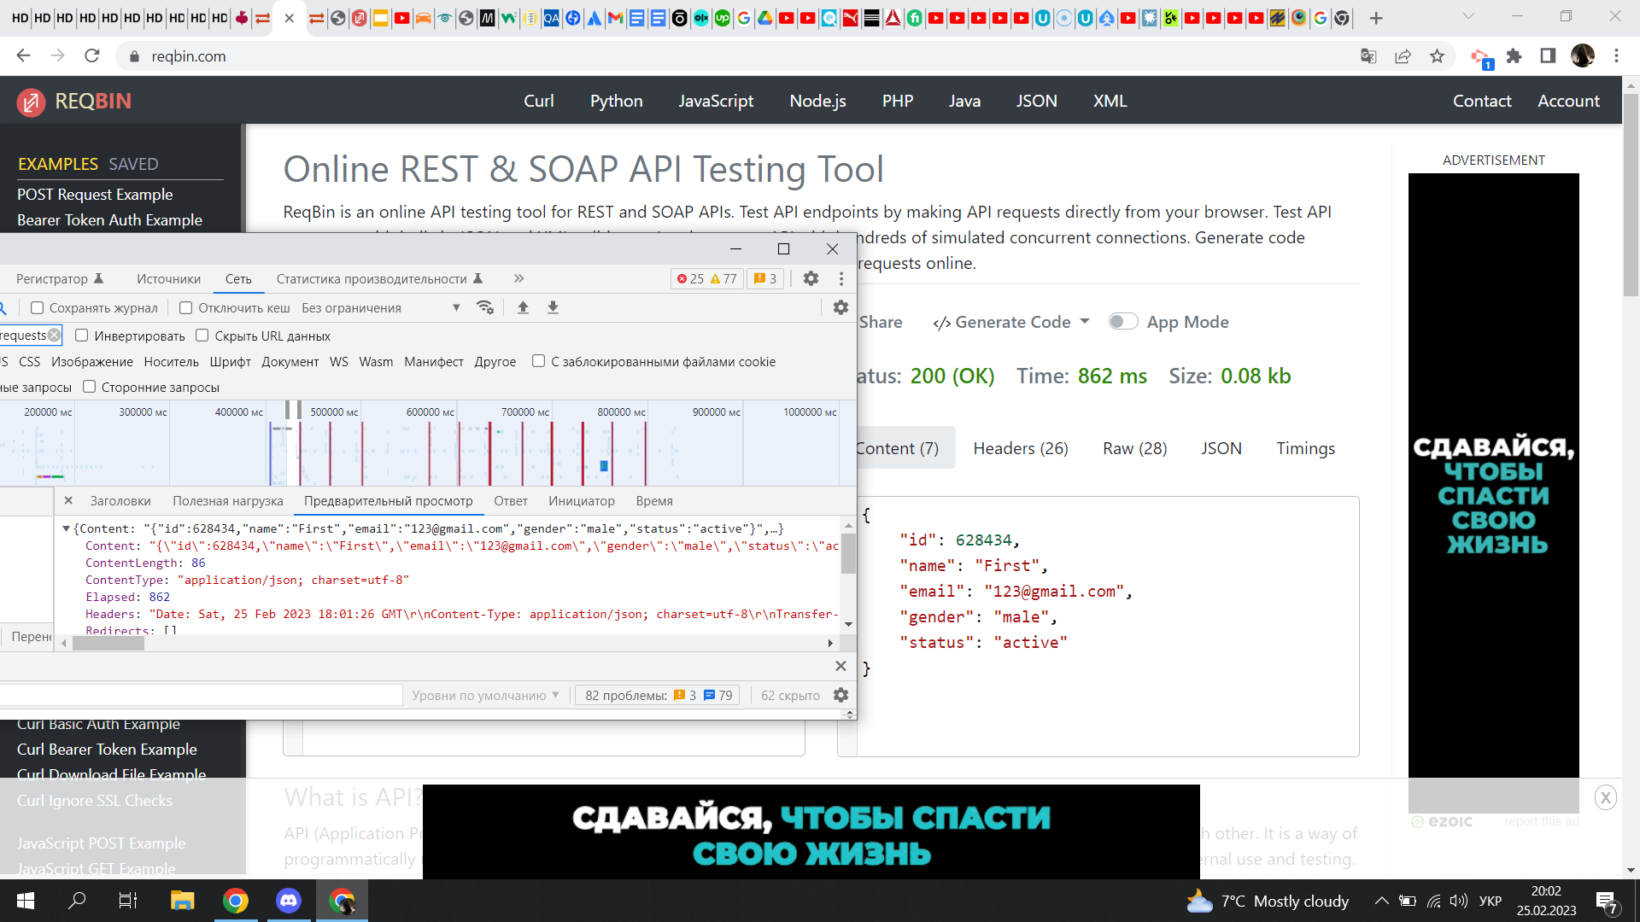

**Update user details**

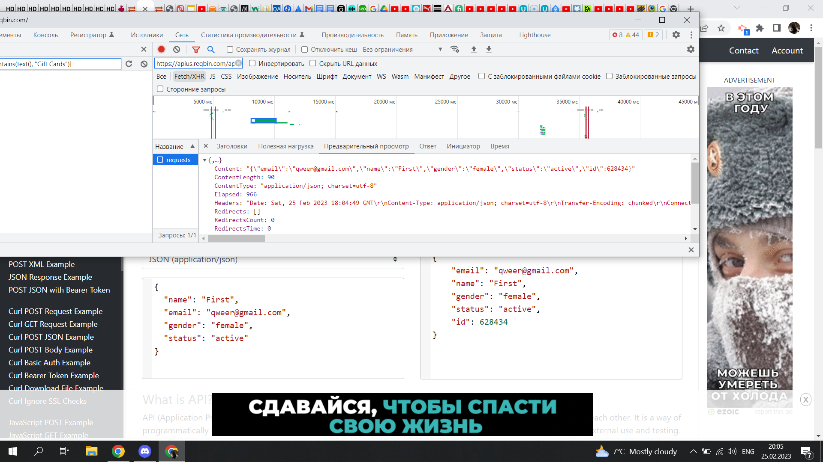

**Delete user**

